Brassmasters | Scale Models
www.brassmasters.co.uk

GREAT CENTRAL RAILWAY
BOGIE FISH VAN

Kit designed by Robin Peover
4MM SCALE
OO - EM - P4

INSTRUCTIONS AND
PROTOTYPE NOTES

PO Box 1137 Sutton Coldfield B76 1FU
Copyright Brassmasters 2016

GCR Bogie Fish Van
The kit is designed as an inner shell with two outer overlays.
1 Remove parts from within parts 1 & 2. Fold in the bottom strip at right angles to the side. It will be found easier to hold between two pieces of angle iron or bar when making folds. Fold in the top strip - this one is angled to form the roof support - check angle from van ends. Fit overlays 2 & 3 to side 1 - note that 3 is slightly longer. Use a low melt solder and solder around the top and bottom edges only.
2 Fit overlays 5 & 6 to end 4. Note that 6 is slightly wider solder around the top and bottom edges. Punch out the rivet detail in the buffer beams.
3 Fit sides to ends - make sure they are square and solder from the inside.
4 Solder overlays 8 & 9 to the doors - these must be the right way up and are right and left handed. The doors fit to the body with the bottom door runner below the van framing. Fit the door runner overlays (parts 19 & 20). The small strapping parts are best fitted with super glue. Punch out the rivet detail in the ventilators (parts 10). Fold and fit to body.
5 Punch out the rivet detail in the solebars (parts 11) and fit to body.
6 Fit body strapping and wire door handrails.
7 Form the roof (part 14) by rolling it around a suitable former and solder in place from the inside.
8 The bogie stretchers are fitted next (parts B3). First solder the 6 BA nut on the topside. Fold up the small locating tabs on the bottom side strip, four in all -they fold up inside the body. Locate the bogie stretchers on these and solder in place.
9 Fit the vacuum stretchers (parts B4) - see drawing for positioning. The inner V-hanger folds down out of the stretcher plate. Fit the outer V-hangers (parts B5) to the outside of the solebars, note the V-hangers are not symmetrical. Fit the cast vacuum cylinders and dummy cylinder support (parts 23) - these are fitted to the outside of the cylinders only, wire up the cast brake link between the V-hangers.
10 Fit the solebar detail (parts 22 and 13) truss rod supports. The truss rod supports are fragile - as soon as they are fitted, bend up and fit the wire truss rods. These are fitted behind the solebars and behind the supports. Note that they are purposely over-length.
11 Punch out the rivet detail in the bogie side frames, 12 in all. Fold up the bogie and fold up the lower strip to rest on the outside of the frame with the half etched line to the outside of the fold. Fit the wheel bearings, temporarily fit the wheels - these should be 12mm diameter with 8 spokes. Bend the brake hangers to fit to the inside of the frames and in line with the wheels. NB for EM and 18.83 gauges, cut short at the etched dot. Fit the bogie pivot cast disc to the body cross stretcher, and the other cast part of the bogie pivot to the top of the bogie.
12 Fit the stepboard supports (brass wire) and stepboards (parts 12). Note that the outer ends of the lower stepboards must be just clear of the bogie. Fit buffers, vacuum pipes and couplings.
Historical notes
The Great Central Railway carried a huge volume of fish traffic, and two types of bogie fish van were built, with slatted or louvered sides. The slatted sided vehicles were built in the GCR works at Dukinfield in 1913-1914. Twenty five were built and numbered 38346-38455 and we believe the louvered sided variant were converted to resemble these in LNER days. The GC livery was body grey roof and lettering white bogies and running gear black. The LNER renumbered them by adding a 5 prefix to their running numbers and painting them all in red oxide with white roofs and white lettering. The running gear was black. A good photograph of one of these vehicles can be found in the ‘Railway Magazine’ for December 1914 page 428. Peter Tatlow’s ‘LNER Wagons Volume 1’ features a poor copy of the photo on page 134-5. The last examples were withdrawn from traffic at about the end of the second world war. We wish to thank John Quick for all his help during the planning of this kit.
Whitemetal castings |  | Required to complete
Axlebox spring | 8 | Wheels (3’ 1” open spoke) and couplings
Oil axlebox | 8 | Wire
Bogie bolster top | 2 | Paint and transfers
Bogie bolster bottom | 2
4 splein buffers | 4
Vacuum brake standpipe | 2
Vacuum cylinder | 1
Vacuum cylinder lever | 1
Westinghouse air brake standpipe | 2

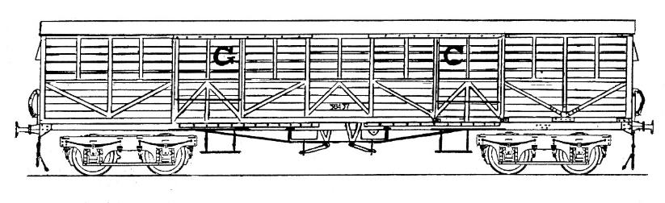 | 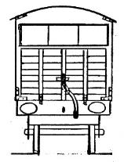

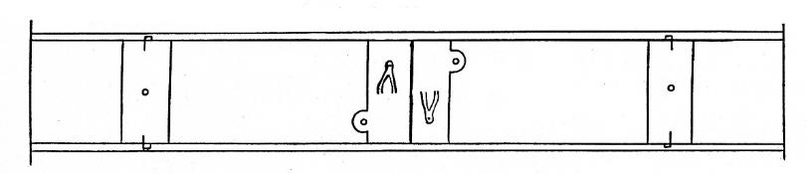 | 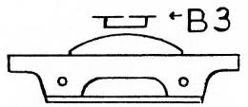
 | 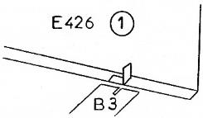
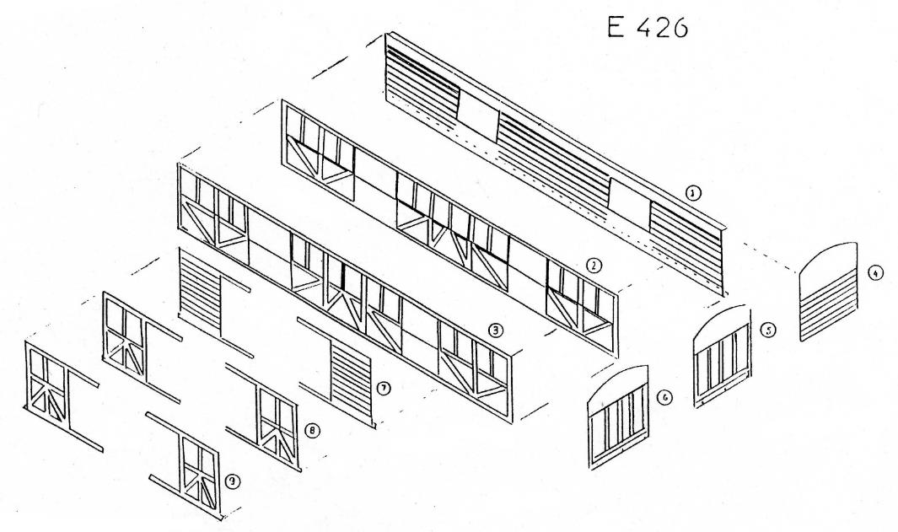

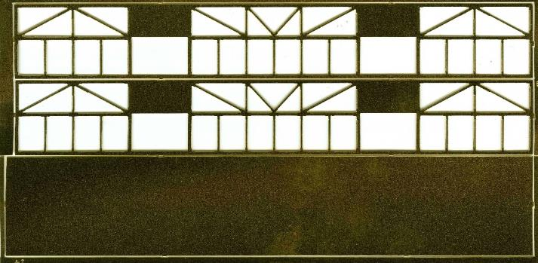 | 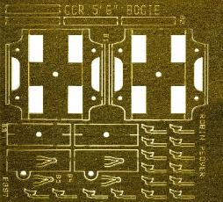
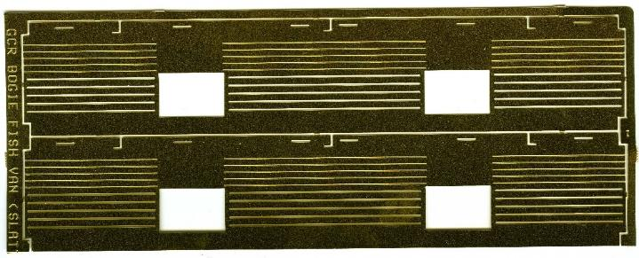 | 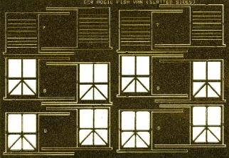
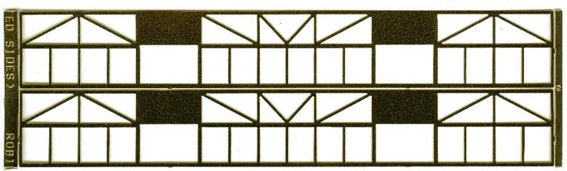 | 