Brassmasters | Scale Models
www.brassmasters.co.uk

GREAT CENTRAL RAILWAY
BOGIE GOODS BRAKE VAN

Kit designed by Robin Peover
4MM SCALE
OO - EM - P4

INSTRUCTIONS AND
PROTOTYPE NOTES

PO Box 1137 Sutton Coldfield B76 1FU
Copyright Brassmasters 2016

GCR Bogie Goods Brake
Historical notes by John Quick
Six vehicles were built at Gorton in 1906. They were numbered in the goods stock series as 9333, 9377, 9448, 9511, 9512 and 9544. The GA of this vehicle is headed 'Goods Brake Van To Carry 10 Tons For Express Goods or Excursion Traffic'. The two compartments either side of the guards van were originally labelled 'Fish and Fruit Compartment To carry Five Tons' In GC days it is believed they were painted grey with white roofs, black solebars and bogies but one picture has been seen of one which shows it in cream and brown passenger livery, but it had a steel look out, unlike the kit and the drawings. In LNER days they were red oxide. They were used on express goods, excursion and newspaper trains and it is believed would have lasted to early BR days.
Instructions
Carefully remove the main body panel from the fret, with a straight edge scribe two lines down the lower body continuing the outline of the guards door. Fold up the sides of the body and fold in the roof supports all bends have a crease line on the inside of the bend. Prepare the van ends fold in the headstocks tack assemble the ends to the sides, ensuring squareness.
Form the side of the guard’s lookout and solder into position the lookout sides - these are soldered into position from the inside. Now fit the two partitions these partitions divide the van into three parts: the guard’s compartment in the centre and two goods compartments at either end. Fit the solebars to the slots in the floor and tack into place.
Take the three parts that make up the sliding doors and solder around the edges bend up and fit the door grab rails [brass wire] and solder to the doors. Fit all four doors to the side of the van and solder through the holes. Fold up and fit the footboards to the solebars. Fit the lower footboards to the supports [brass wire].
Fit the solebar headstock plates. Next, fit the outer V hangers to the solebars and the inner ones to the floor. The cast vacuum cylinders can now be fitted. Wire up the cast brake link between the V-hangers. Fold up and fit the van end vents. The draw hook plates and buffers can now be fitted.
Form the roof by rolling it around a suitable former. After spraying, the glazing can be fitted. Fit the door T-handles bend up the guards’ grab rail [brass wire]. Fit the roof chimney and lamp top.
Bogies
Remove both side frames from the fret and push out the rivet detail from the rear. First fold up the top lip of the bogie. The two halves can now be folded up and soldered through the two holes in the rear.
Fold up the ends and fold down the fold up part 3 and solder to part 4. Lift up the tabs on parts 1 & 2 and slide into position the prepared parts 3 & 4. Close up the tabs. Fit the wheel bearings and wheels fold down the brake hangers and fit the brake pull rods (part 6). Fold up and fit the stepboards (parts 7 & 8). Fit the cast axle/boxes and springs and the cast bolster springs. Solder into position the press studs or nuts as desired.
Whitemetal castings |  | Required to complete
Bogie centre spring | 4
Axlebox spring | 8 | Wheels (3’ 7” Mansell) and couplings
Oil axlebox | 8 | Wire 0.45mm and 0.3mm for detailing the underframe
Guard’s lookout | 2 | Press studs or nuts and bolts for bogies
Stove chimney | 1 | Paint and transfers
Long buffers | 4
Vacuum brake standpipe | 2
Vacuum cylinder | 1
Vacuum cylinder lever | 1
Westinghouse air brake standpipe | 2
Oil pot lamp top | 1

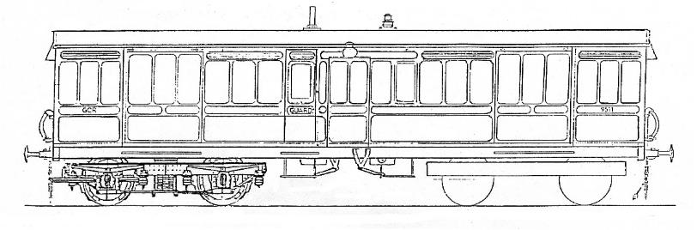 |  | 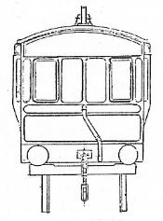
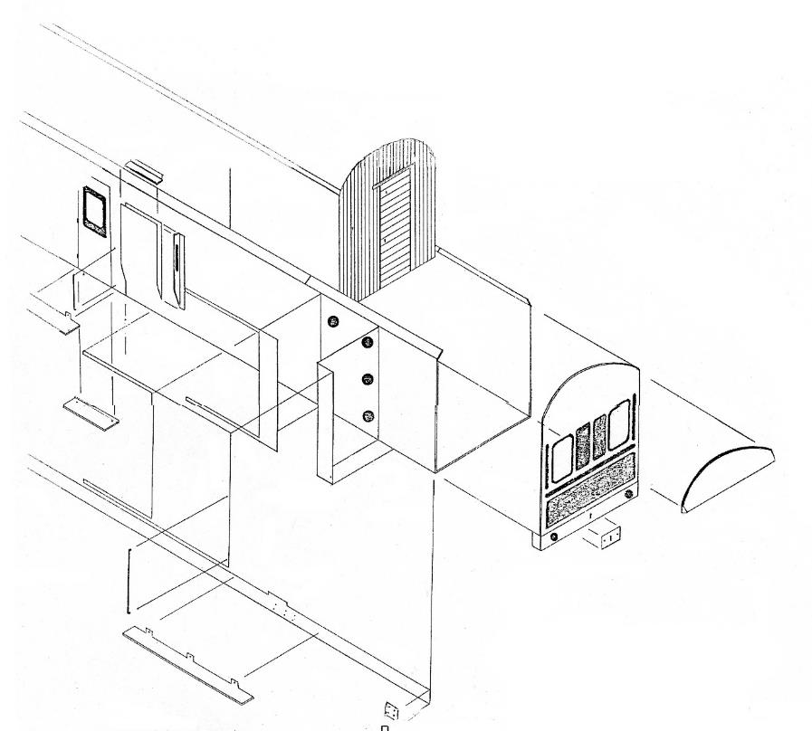
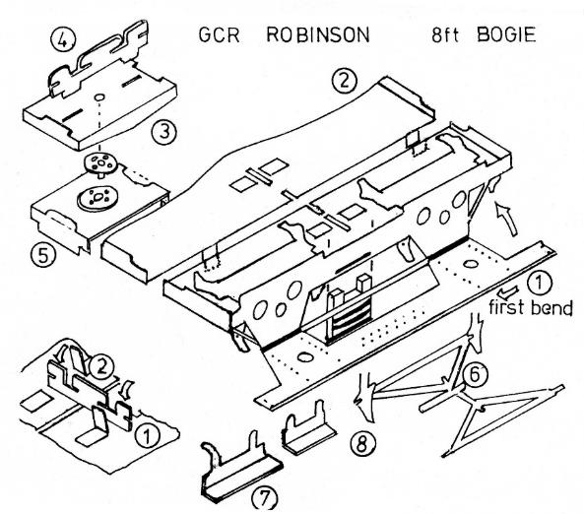 | 