Brassmasters | Scale Models
www.brassmasters.co.uk

GREAT CENTRAL RAILWAY
DIAGRAM 17/17A
and
CLC DIAGRAM 47/48 10T VAN

Kit designed by Robin Peover
4MM SCALE
OO - EM - P4

INSTRUCTIONS AND
PROTOTYPE NOTES

PO Box 1137 Sutton Coldfield B76 1FU
Copyright Brassmasters 2016

GCR Diagram 17/17A and CLC Diagram 47/48 10T van
Builders are advised to read these notes before deciding on the version they wish to build.
GCR Diagram 17
GCR construction began in 1912 at the GC works at Dukinfield and over 900 were built over a two year period. They went into GCR stock and were allocated numbers in the ranges 37855-38426, 42495-42794, 42795-42820.
Most of the vans were taken into LNER stock and became code 5094. Wheels 3’ 1½” were fitted with 8 split spokes. Hand brakes were fitted to one side of the vehicle only. GCR livery was body - lead grey, roof and lettering white, sole bars and running, gear black
Cheshire Lines Committee Diagram 47/48
These vans were built from GCR diagram 17 - none were built to diagram 17/A.
CLC diagram 47 became LNER diagram 43B code 5051. They were built without external end stanchions, but had them fitted by 1930. Nos. 1858-1857 and 3831-4070 were built in 1912 by Metropolitan, Carriage Wagon & Finance Co at their Oldbury works – a total of 270 vans.
CLC diagram 48 became LNER diagram- 43F code 5055. They were built with external end stanchions. Nos 1858-1878 were built in 1915 by the GCR at Dukinfield – a total of 21 vans.
In 1930, 97 vans were sold to the LMS and 194 vans to the LNER where they were given LNER numbers between 545028-545578 and possibly 545265-545458. Of these 194 vans, there were 153 still in stock at December 1944, .but none were left by June 1963 when both LNER diagrams were cancelled.
CLC livery was body: solebars, headstocks, buffers, wheel tyres light lead grey. Roof, brake handles and lettering were white. Couplings and all other parts below the solebars were black.
GCR diagram 17/A
In 1913 the GCR ordered a further 100 vans with automatic vacuum brakes. These vans became diagram 17/A, and were given numbers 37753-37852. Near the end of its existence, the GCR built more vans of diagram 17/A - these went directly into LNER stock and were coded 5050.
The LNER added a 5 to the GCR running members. The unfitted vans were still be painted grey in LNER ownership but the vacuum fitted ones were painted red oxide.
LMS vans from the CLC had cross bracing fitted to the doors. The numbering at first appears to be random, numbers between 35791 and 359320 were used. The first LMS livery would have been red oxide.
Acknowledgements
For historical notes we would like to thank John Quick, Bob Miller and Chris Crofts.
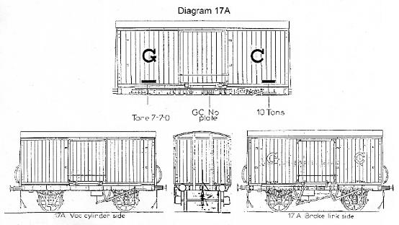 | 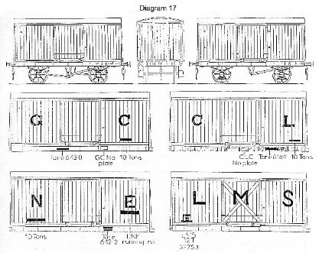

Diagram 17 instructions
Identify all the parts on the fret. All bends in the kit have an etched line on the inside of the bend.
Solder is the recommended method of fixing the parts together. Remove the floor and sides push out the rivet detail from the back and fold up the sides and fold in the roof supports.
Remove the van ends, push out the rivet detail from the back and carefully tack the ends to the body. Solder into position the headstock thickening pieces. Fold down from the floor - the eight outriggers so they rest on the face of the solebars.
Solder the solebars into position and fold up and fit the four solebars to headstock brackets. Fold up the W-irons and push down from the floor the W-iron mounts. If the W- irons do not fit in the centre of the solebars, turn the W-irons around the other way and, when centred, solder into position. Fold up the bottom axle/box keep - this just rests on the face of the W-iron.
Fit the doors - first fold under the door thickening on the sides. Fit the eight door stops to the van sides. Fit the door handles from brass wire. Fit the top and bottom door rivet strapping. Fold in this strapping top and bottom on the far ends - this fits to the slots in the van body. Solder the doors to the body - from inside the van. Fit the corner strappings to the doors.
Fold down from the floor, the W-irons and V hangers one side only before the handbrakes are fitted. Fit the wheel bearings and axleboxes and springs. Thread onto brass wire the brake actuating levers and string between the V-hangers. Bend up the handbrake handles, fold up the hand brake guides and solder to solebars. Complete the brake rigging by fitting the brake hangers. Fit to the solebars the number plate - see drawings for position. Fit the end stanchions, if required for the model you are building. Fit buffers and the roof, either from the etch supplied or from 15 thou plasticard if preferred.
Diagram 17/A instructions
Proceed as with diagram 17 as far as the brake V-hangers. For diagram 17/A, three V-hangers are fitted to the outside of the solebars. The handbrakes are shorter - see drawing for detail.
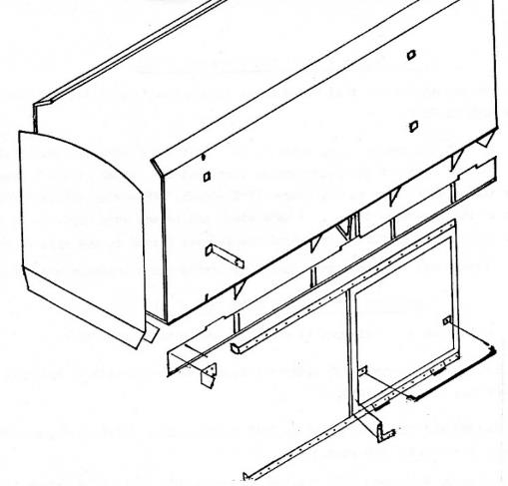 | 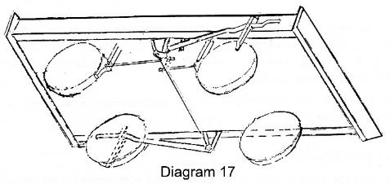
 | 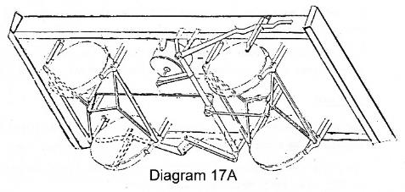
Whitemetal castings
Buffers | 4 | Required to complete
End stanchions | 4 | Wheels (3’1“ split-spoke)
Axlebox Spring | 4 | Couplings
Axlebox | 4 | Wire
Vacuum Brake Standpipe | 2 | Paint and transfers
Vacuum Cylinder | 1
Vacuum Cylinder lever | 1
Westinghouse Air Brake Standpipe | 2

